“Justifications” and Motivations for Imperialism
Source: French economist Paul Leroy-Beaulieu, On the Desirability of Imperialism, published in Paris, 1891

It is impossible not to consider imperialism as one of the tasks imposed on the civilized states…The present-day world is composed of four different categories in terms of types of civilization. First is that of Western civilization--our own part. A second part is inhabited by people of a different civilization, organized in compact, coherent and stable societies and destined by their history and present character to govern themselves--the Chinese and Japanese peoples for example. In the third part live peoples advanced enough in some respects, but ones which have deteriorated....Finally, a great part of the world is inhabited by barbarian tribes or savages, some given over to wars without end and to brutal customs, and others knowing so little of the arts and being so little accustomed to work and to invention that they do not know how to exploit their land and its natural riches. They live in little groups, impoverished and scattered, in enormous territories which could nourish vast numbers of people with ease. This state of the world implies for the civilized people a right of intervention in the affairs of the peoples of the last two categories.

It is neither natural nor just for the civilized people of the West to be cooped up indefinitely and jammed into the restricted spaces which were their first home. Nor is it natural and just that they there accumulate the marvels of science, the arts and civilization, that they see the rate of interest fall more each day for lack of good investment opportunities, while they leave perhaps half the world to little groups of ignorant, ineffectual men who are like feeble children…

Imperialism is often confused with commerce or with the opening of commercial markets. . . . Imperialism means something quite different from the sale or purchase of commodities. It entails a profound action on a people and a territory, providing the inhabitants with some education and regular justice, teaching them the division of labor and the uses of capital when they are ignorant of these things…Such a transformation of a barbarian country cannot be accomplished by simple commercial [trade] relations. Imperialism is thus the systematic action of an organized people upon another people whose organization is defective; and it presupposes that it is the state itself, and not only some individuals, which is responsible for the mission.

The great value of colonies . . . is not only that they serve to catch the overflow population of the mother country, nor even that they open a particularly reliable area of investment for excess capital [wealth], it is also that they give a sharp stimulus to the commerce [trade] of the country, that they strengthen and support its industry and growth…These advantages resulting from the prosperity of the colonies are not limited just to the mother countries; they extend to all the countries of the old world and in fact there is not a nation which does not derive a real benefit from this increase in the productivity of humanity…

Imperialism has caused the opening of new sources of production. . . . It is thus that unknown products have been brought to the consumers of Europe to increase their comfort. . . . That is the first and incontestable result of imperialism. And this is the second: It is to open new markets for the sale of products manufactured in Europe, markets more profitable and more expandable than those we have been limited to previously, because the new societies have an ability to grow…

Source: Founder of the De Beers Diamond Consortium Cecil Rhodes, “Confession of Faith” letter, 1877

Just fancy [think of] those parts that are at present inhabited by the most despicable specimens of human beings. What an alteration there would be if they were brought under Anglo-Saxon [white] influence… Why should we not form a secret society with but one object, the furtherance of the British Empire and the bringing of the whole world under British rule, for the recovery of the United States, for making the Anglo-Saxon [white] race but one Empire?… Africa is still lying ready for us, it is our duty to take it. It is our duty to seize every opportunity of acquiring more territory…If the whites maintain their position as the supreme race, the day may come when we shall all be thankful that we have the natives in their proper place…

Source: THE FOUR HUMAN RACES, ILLUSTRATION IN THE STANDARD SOCIAL STUDIES TEXTBOOK USED IN FRANCE DURING THE 1880s AND 1890s

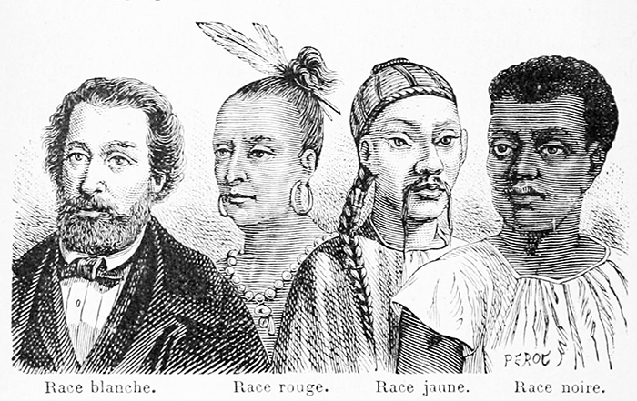
A caption below the image reads:
“The White Race, the most perfect of the human races, lives mostly in Europe, West Asia, North Africa, and North America. It is characterized by its oval head and rather thin lips. The complexion may vary in color but is generally light.

The Yellow Race occupies mostly East Asia, China, and Japan. It is characterized by its high cheekbones and almond- shaped eyes.

The Red Race, which once upon a time inhabited all of North and South America, has reddish skin, deeply set eyes, and a long and arched nose.

The Black Race, which occupies mostly Africa and the southern parts of Oceania, has skin that is very dark, dark brown eyes, and curly hair.”

Karl Pearson, British Professor of Mathematics, Lecture titled “National Life from the Standpoint of Science,” 1900

History shows me one way, and one way only, in which a high state of civilization has been produced, namely, the struggle of race with race, nation against nation, and the survival of the physically and mentally fitter race…In the early days of that struggle it was a blind, unconscious struggle of barbaric tribes…The struggle means suffering, intense suffering, while it is in progress; but that struggle and that suffering have been the stages by which the white man has reached his present stage of development…At the present day, in the case of the civilized white man, it has become more and more the conscious, carefully directed attempt of the nation to fit itself to a continuously changing environment.

You will see that my view of a nation is that of an organized whole, insuring that its people are substantially recruited from the better stocks, and kept up to a high pitch of external efficiency by contest, chiefly by way of war with inferior races, and [war] with equal races in the struggle for trade-routes and for the sources of raw material and of food supply…You may say: Let us cease to struggle; let us leave the lands of the world to the races that cannot profit by them to the full; let us cease to compete in the markets of the world. Well, we could do it, if we were a small nation living on the produce of our own soil, and a soil so worthless that no other race envied it and sought to appropriate [use] it. We should cease to advance; but then we should naturally give up progress as a good which comes through suffering. . . The man who tells us that he feels to all men alike…that he has no patriotic sentiment, that he loves the Kaffir [African] as he loves his brother, is probably deceiving himself…A nation of such men will not stand for many generations; it cannot survive in the struggle of the nations, it cannot be a factor in the contest upon which human progress ultimately depends. The national spirit is not a thing to be ashamed of…

